Saturday September 14: How to Help a Friend

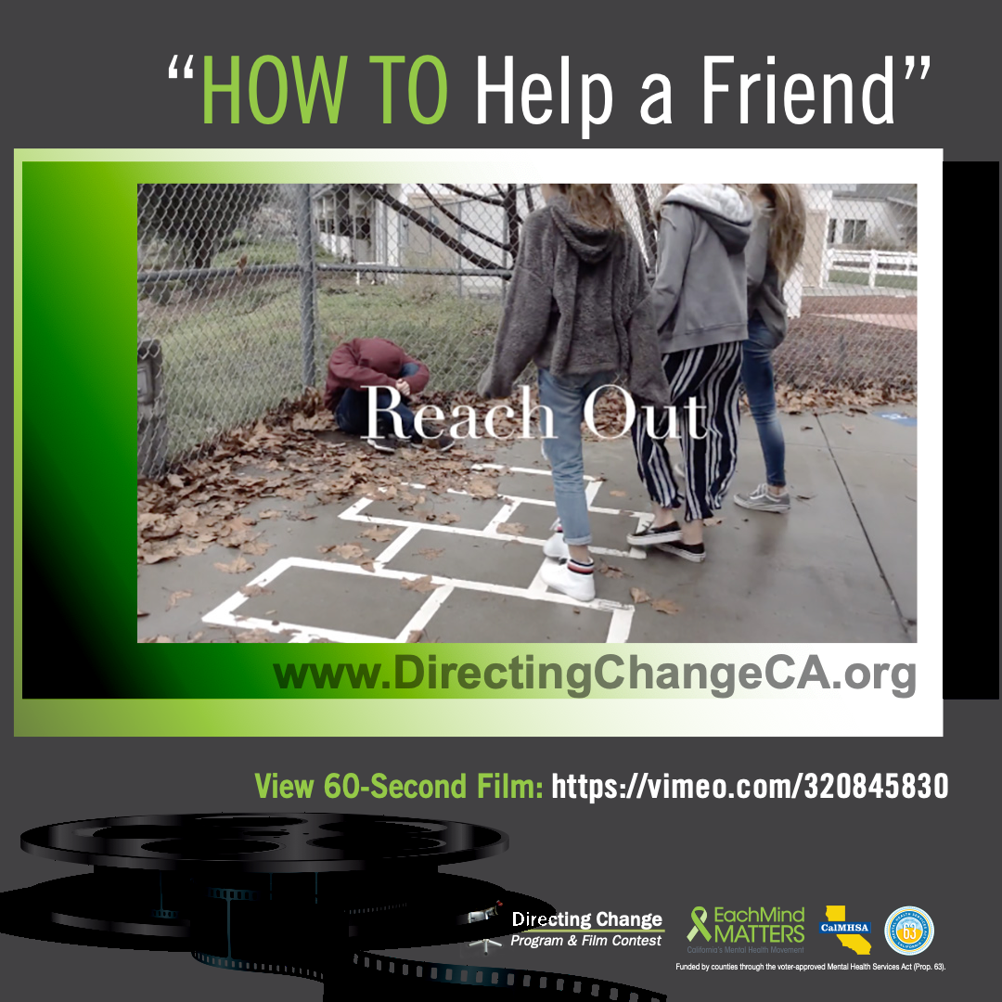

Talking about suicide can be daunting, but the more you know, the easier it is to start those conversations. Both youth and adults can benefit from learning to recognize when someone is in need. Learn about the warning signs for suicide here: http://www.directingchangeca.org/suicide-warning-signs/. For more information on what to do after recognizing the warning signs, check out this
a list of things that you can say, and resources to connect them to here: http://www.directingchangeca.org/wp-content/uploads/2019_DirectingChange_SuicidePreventionFactSheet.pdf.

Additionally, these conversations can look different depending on the age of your audience. For a younger audience, check out the Directing Change lesson plan: Superheroes and Purpose. This lesson plan was designed with middle school teachers and includes activities and conversation starters specifically created to discuss the subject with 6th – 8th grade students. Lesson plan can be downloaded from the Directing Change website: http://www.directingchangeca.org/wp-content/uploads/Superheroes-and-Purpose-Lesson-Plan.pdf.

To view and download free educational resources, activity ideas, and films, visit: www.directingchangeCA.org or access the Each Mind Matters Suicide Prevention Week Activation Kit at https://www.eachmindmatters.org/spw2019/

Highlighted Film: How to Help a Friend

Created by Matisse Koser from San Pasqual Union, San Diego County
- View film: https://vimeo.com/320845830
- A girl notices some warning signs of suicide in a classmate and tells her friends about it. They go together as a group to reach out to their classmate, listen to his story, and take him to a trusted adult for help.

- Share the film: Who would you reach out to if you were worried about a friend? This film follows a group of friends as they discover a classmate’s struggles and reach out to a trusted adult at school https://vimeo.com/320845830 #SPweek2019 #directingchange #bethe1to #reachout #middleschool #sandiego

About Directing Change: The Directing Change Program & Film Contest is an evaluated youth engagement program. Directing Change engages students and young people throughout California to learn about the topics of suicide prevention and mental health by creating short films that are used to support awareness, education, and advocacy efforts on these topics. Youth apply knowledge about mental health and suicide prevention to create their own unique message about suicide prevention for their peers. Through the creative process of filmmaking young people are engaged via all methods of the learning spectrum: to see, experience, discuss, and apply. These students are recognized for their efforts at a red-carpet award ceremony and their films help impact social change at their schools and in their communities. Directing Change is part of Each Mind Matters: California's Mental Health Movement and statewide efforts to prevent suicide, reduce stigma and discrimination related to mental illness, and to promote the mental health and wellness of students. These initiatives are funded by counties through the Mental Health Services Act (Prop 63) and administered by the California Mental Health Services Authority (CalMHSA), an organization of county governments working to improve mental health outcomes for individuals, families, and communities.

