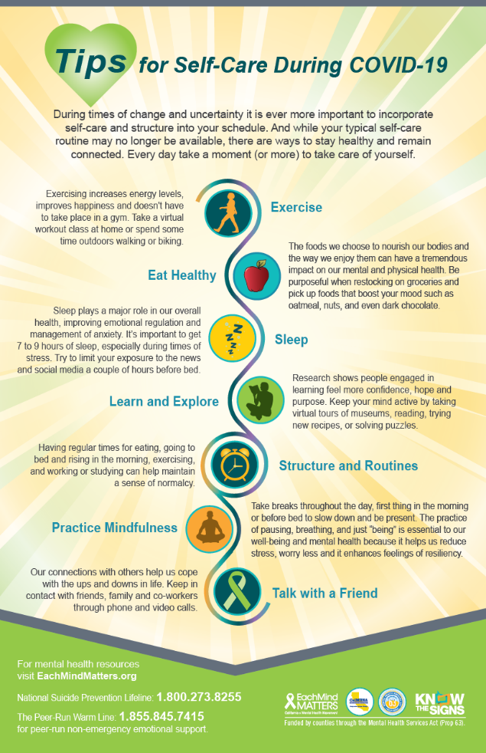
TWITTER
While your daily #selfcare routine may have changed, there are many ways you can remain healthy and connected during #COVID19, 🌳🏃‍♀️😴whether you have a couple of hours or a couple of minutes. #EachMindMatters #mentalhealth

FACEBOOK
As we settle into new routines at home and physical separation from others, it's especially important to take time each day for #selfcare. Here are ways to remain healthy and connected during #COVID19, 🌳🏃‍♀️😴 whether you have a couple of hours or a couple of minutes. #EachMindMatters #mentalhealth
Share this infographic by tagging friends in the comments. Get the entire household involved by printing out a copy and sticking it on your refrigerator!

INSTAGRAM
As we settle into new routines at home and physical separation from others, it's especially important to take time each day for #selfcare. Here are ways to remain healthy and connected during #COVID19, 🌳🏃‍♀️😴 whether you have a couple of hours or a couple of minutes.
Share this infographic by tagging friends in the comments
#EachMindMatters #mentalhealth #coronavirus #healthandwellness #athome #mentalwellness #reading #rest #sleep #wellbeing #mentalillness #depression #anxiety #stress #walk
Download the graphic from the EMM Resource Centre:
https://emmresourcecenter.org/resources/tips-self-care-while-practicing-social-distancing

