First Responders and Suicide Prevention: Issue Brief and Talking Points
Take-Home Points
- Community suicide prevention efforts should include first responders as partners, and also support efforts to reduce suicide risk among first responders themselves.
- Many first responder agencies are developing strategies to promote mental wellness and reduce suicide risk.
- Strategies that include strong leadership, early intervention protocols, enhanced training and education, and access to “safe” and culturally competent support networks (such as peers and specially trained mental health providers), are the most promising.
- There are ways to support these efforts from outside of first responder agencies, and county and community partners are encouraged to reach out to offer expertise and support where it may be needed.

Why Focus on First Responders and Suicide Prevention?
The theme of this toolkit is Finding Purpose: Taking Care of Ourselves and Others. Few professions exemplify this theme more than first responders. For the purposes of this data brief the term first responder includes individuals working as firefighters, law enforcement officers and in emergency medical services (EMS). In some communities, first responders may also include mobile crisis units consisting of mental health clinicians, chaplains, coroner and medical examiner personnel, dispatchers and others.

As professional helpers, first responders are key partners in community suicide prevention, however the stresses of the job can also mean that first responders will themselves need help and support throughout their careers. The following data brief has been developed to assist your agency is gaining a better understanding of the mental health concerns faced by first responder, offer insight around cultural competency in working with first responders, and provide some suggestions to provide supports.

We hope you will use this information to deepen your understanding and find your role for supporting first responders in your community.

Crisis Support Resources for First Responders

Safe Call Now:

Call 206-459-3020

https://www.safecallnowusa.org/

Safe Call Now is a confidential, comprehensive, 24-hour crisis referral service for all public safety employees, all emergency services personnel, and their family members nationwide

Cop Line:

Call (800) 267-5463
  - www.copline.org/

24-hr Crisis Line staffed by retired law enforcement officers to provide a safe, confidential resource for law enforcement officers and their families.

Background on Suicide Risk and Mental Health Concerns
among First Responders

It is difficult to compare suicide rates among first responders with other groups or the general population. Surveillance systems do not systematically receive and report data on occupations, so much of the available data comes from sources that receive information about some, but not all, first responder suicide deaths.

The CDC Suicide Rates by Occupational Group MMWR Weekly Report from 2016 reported data from 17 states that participate in the National Violent Death Reporting System. An Erratum was published in 2018 to correct some inaccuracies in the initial report. Although “First Responder” is not one of the Standard Occupational Codes included in this database, Protective Services includes firefighters and law enforcement (but not EMTs). This data showed that rates within these occupations were higher than the general population, and also suggested that females working in these fields are at higher risk than expected when looking at general population trends by sex. Some explanations may include that certain protective factors, such as social connectedness, may be less prominent for females in occupations that remain male-dominated.

The Ruderman Family Foundation White Paper on Mental Health and Suicide of First Responders compiled information from multiple private sources, such as the Firefighter Behavioral Health Alliance, Badge of Life, interviews with experts, and review of the behavioral health literature. The report suggested that the rates presented were likely to be underestimated.

One study found that police officers are more likely to die by suicide than by homicide or accidents

Although a system for collecting accurate data on suicide death rates for first responders has not been developed, there have been studies examining risk factors and prevalence of suicide thoughts and behaviors among first responders.

In 2018 SAMHSA’s Disaster Technical Assistance Center issued a research bulletin, “First Responders: Behavioral Health Concerns, Emergency Response, and Trauma”. The bulletin reported that first responders are at higher risk for Post-Traumatic Stress Disorder, depression, and substance abuse, than the general population and that these risk factors may put them at higher risk of suicidal behavior.

According to one study focused on firefighters, the career prevalence estimates of suicide ideation, plans, attempts, and non-suicidal self-injury were found to be 46.8%, 19.2%, 15.5%, and 16.4%, respectively. For law enforcement officers, a U.S.-based sample of 115 police officers in a midsize urban police department, revealed lifetime prevalence of suicidal ideation of 25% and 23.1% for females and males, respectively. These rates are shown to be elevated compared to the general U.S. population of which approximately 13.5% of individuals report lifetime ideation

A 2018 study published results from analysis of several years of data from Arizona to conclude that EMTs were 1.39 times more likely to die by suicide than non-EMTs.

First Responders - Risk and Protective Factors

Risk Factors
First responders are often exposed to stressful and life-threatening situations and numerous traumatic incidents, including individuals in suicidal crisis or who have made a serious attempt. They are tasked with gaining control of very challenging situations and administering potentially lifesaving interventions. It is not just the initial moment of crisis that can have harmful effects. The feelings that first responder carry with them after such emotionally charged incidents represent a more enduring source of stress. With the heavy responsibility inherent in first responder professions and the exposure to a range of traumatic circumstances comes the potential for problems that can lead to increased suicide risk among first responders.

The article, A Systematic Review of Suicidal Thoughts and Behaviors Among Police Officers, Firefighters, EMTs, and Paramedics, offers a succinct summary of the risk factors experienced by first responders. The study notes “first responder occupations carry inherent risks that pose acute and chronic dangers to one’s health and safety”. The authors go on to cite that “these experiences may lower one’s fear of death”, and that “shift-work may cause sleep disturbances and disruptions in familial social support, both of which are potent risk factors for suicide”. In addition, it is noted in the study that first responders may have access to highly lethal means, and that first responders are “overwhelmingly comprised of white males…the same demographic group that is also at the highest risk for suicide”.

First responders are accustomed to being the helpers, the ones charged with gaining control of difficult situations, and they may be reluctant to ask for help for themselves. There can be self-imposed as well as cultural or institutional pressure to appear tough or unimpacted by extremely difficult experiences. This can lead to unhealthy coping strategies, such as drinking to excess. Also, of concern is the issue of “perceived jeopardy”, or worry that seeking help or even admitting to mental health challenges could jeopardize one’s employment or prospects.

Certain life circumstances can increase risk, such as the loss of a partner or spouse, involvement with a critical incident such as a shooting or the death of a child. Significant changes in routine, such as retirement or change of duty, can also pose increased risk.
It’s worth noting that studies have also shown that factors related to organizational structure and climate can be an even greater source of stress for the first responders. For example, one study noted that “Shift schedules that disrupt sleep patterns and social life, authoritarian management styles, poor interpersonal relationships with supervisors, interdepartmental politics, lack of adequate planning and resources, lack of promotion and transfer opportunities, excessive paperwork, lack of autonomy in performing duties, and lack of recognition for work accomplishments” are also among the stressors faced by first responders.

Protective Factors
First responders also experience many rewards in their opportunities to help individuals and communities and save lives. Their role offers a strong sense of purpose and meaning. Having good problem solving and coping skills, as well as opportunities to work through the impacts of traumatic experiences, can increase resiliency.
There is a strong sense of connectedness among first responders, who view one another as family, and watch out for each other’s backs. It is also helpful to have a strong social network off the job, such as supportive and understanding family, spouses, and communities.
A workplace culture of safety that includes behavioral as well as physical health can help promote resiliency through challenging situations. Just as exercise and routine physicals to keep the body healthy are necessary to identify and respond to health problems, it is necessary to actively counter the cumulative effects of stress on mental health.

Comprehensive suicide prevention programs tailored to the work environment may significantly impact suicide rates if repeated throughout careers. One effort to reduce suicide among law enforcement officers by focusing on upstream prevention in the form of resiliency training, showed promising results. The Montreal Police Department saw a 79% decrease in suicides and no comparable decrease in suicide deaths in police elsewhere in the Province of Quebec, where no similar police suicide prevention program was initiated.

The difference between promoting physical fitness and safety, and promoting mental wellness, lies in the stigma that is often associated with mental health problems. Formal programs as well as informal interactions between peers and chain of command are all opportunities to communicate that it is OK to not be OK, and that everyone can use help at times.

Warning Signs

- Talking about wanting to die, seeking revenge, feeling hopelessness, being trapped, being a burden to others, or being in unbearable pain
- Displaying increased risk-taking behavior or recklessness
- Looking for a way to kill oneself
- Being emotionless, numb, angry, agitated, anxious, or enraged or showing extreme mood swings
- Giving away valued possessions
- Being socially isolated or withdrawn
- Gaining or losing weight
- Experiencing sleep deprivation or sleeping too much
- Increasing consumption of alcohol or drugs
Warning signs are especially important if the behavior is new, has increased, or seems related to a painful event, loss or change.

Considerations for First Responders in the Wake of Disasters

Over the past few years, California has been subjected to several natural disasters, often in the form of devastating fires. The incidents have the potential to put an extreme level of trauma and stress on first responders.

The Substance Abuse and Mental Health Services Administration (SAMHSA) developed “Disaster Technical Assistance Center Supplemental Research Bulletin, First Responders: Behavioral Health Concerns, Emergency Response, and Trauma”, which addresses a variety of issues faced by first responders in responding to disasters as well as the toll of the work in first responder fields in general.

Specific to disaster response, here are a few items noted in the bulletin:
- Another team of investigators found that life events, including personal trauma and loss prior to the disaster, were associated with increased risk of post-disaster mental health issues (Brooks et al., 2016).
- Specialized training, elevated level of professional mastery, and assurance in personal and team capabilities acted as protective factors and were associated with reduced stress (Brooks et al., 2015; Brooks et al., 2016).

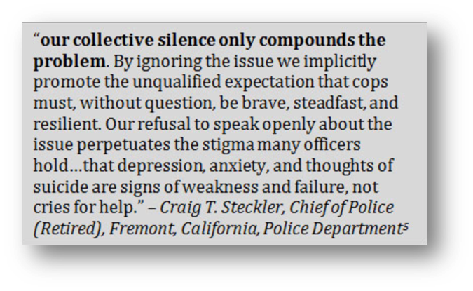
From: https://cops.usdoj.gov/html/dispatch/06-2014/preventing_officer_suicide.asp
Strategies to Support First Responders

The multi-level strategies below are derived from the Workplace Blueprint for Suicide Prevention (reviewed in the 2018 Suicide Prevention Week Toolkit) and from “Breaking the Silence”, a national strategy to address officer mental wellness and suicide prevention within law enforcement. Breaking the Silence is a report and video generated from a Law Enforcement Officer Suicide and Mental Health symposium held in 2013. A video is also available that provides an overview of the issue from the perspective of officers.

The strategies fall under four categories:

- Culture change: leadership, messaging, wellness orientation, and organizational policies
- Prevention and early intervention protocols and access to culturally competent and peer-based mental health support
- Training and education in suicide prevention as well as building resiliency, for first responders and their families
- Postvention and event response protocols for critical incidents and after a suicide

Culture Change

Leadership.
Leadership plays a central role in shifting the culture toward wellness by speaking out often about the importance of mental health and how to support someone in a crisis. As professional helpers, many first responders are reluctant to see themselves as needing help, and may feel shame, embarrassment, or reduced self-worth. When leaders communicate comfortably and directly about these topics, it sends the signal that “it’s OK to not be OK”, and that help is not only available but encouraged.

- The International Association of Chiefs of Police, Law Enforcement Suicide Prevention and Awareness has created resources for chain of command leaders to improve and strengthen suicide prevention efforts:
https://www.theiacp.org/resources/document/law-enforcement-suicide-prevention-and-awareness

Safe and Effective Messaging on Suicide Prevention

Resources that offer guidelines for messaging around suicide prevention and mental health can be useful in reducing the stigma around reaching out for help. First responders have a key role to play in their interactions with witnesses, survivors and others experiencing a suicide crisis or aftermath of a suicide and are frequently in a position to speak with the media; changes in outward-facing public messaging can also shift how first responders themselves think and act when they or their peers are experiencing challenges.

Promoting Wellness

Internal campaigns can be effective ways to change the culture around suicide and mental health and build a social safety network to promote wellness. Highlighting peers who are willing to share their stories of hope can be especially powerful.
- This article, “Responder opens up during National Suicide Prevention Week” is a good example of a peer firefighter sharing his story about what led him to seek help, and how he has become an inspiration for change within his department.
Stress-relieving events, ranging from health fairs to wellness programs, games and social gatherings, can also help build relationships and blow off steam.
- This article describes how yoga has been embraced by firefighters as a way to build physical, and mental strength and flexibility: https://inpublicsafety.com/2019/05/how-yoga-combines-wellness-and-physical-training-for-firefighters/

The article from PoliceOne.com, “7 ways to prevent police suicide by focusing on overall officer well-being”, provides a succinct overview of ways to promote officer well-being.

Policies and Procedures. Changing culture also means being willing to critically examine how things unfold when a crisis arises, and identify if career jeopardy, or negative consequences on employment or prospects, is an inevitable outcome.

Many first responders work long shifts, with unusual hours, and taking time off for self-care is difficult. Policies that allow for the flexibility to seek help when needed, taking time off for treatment, and promoting a culture of safety that includes occupational stress can help alleviate these barriers.

Early Recognition and Intervention Protocols

Having policies and procedures in place for early intervention helps ensure everyone knows what to do when problems arise. The early recognition and intervention plan should include education and training on recognizing and responding to suicide risk, as well as specific points to check in with peers and staff. Including access to confidential screening tools can be helpful. Include steps to assess potential at-risk groups for early warning signs of mental health issues such as recent retirees, disabled officers, and veterans.
The plan should also incorporate culturally competent mental health supports, such as staff mental health providers, or a vetted list of community providers who are specifically trained to work with first responders.
Peer Support
First responders share a strong sense of connectedness and camaraderie that can extend to supporting one another’s mental health. Opening up in a safe group setting among trusted peers can help counter stigma and feelings of shame related to the challenges being experienced. Peer support groups can also facilitate sharing of problem-solving and coping skills that have worked for others.
Employee Assistance Programs (EAP).
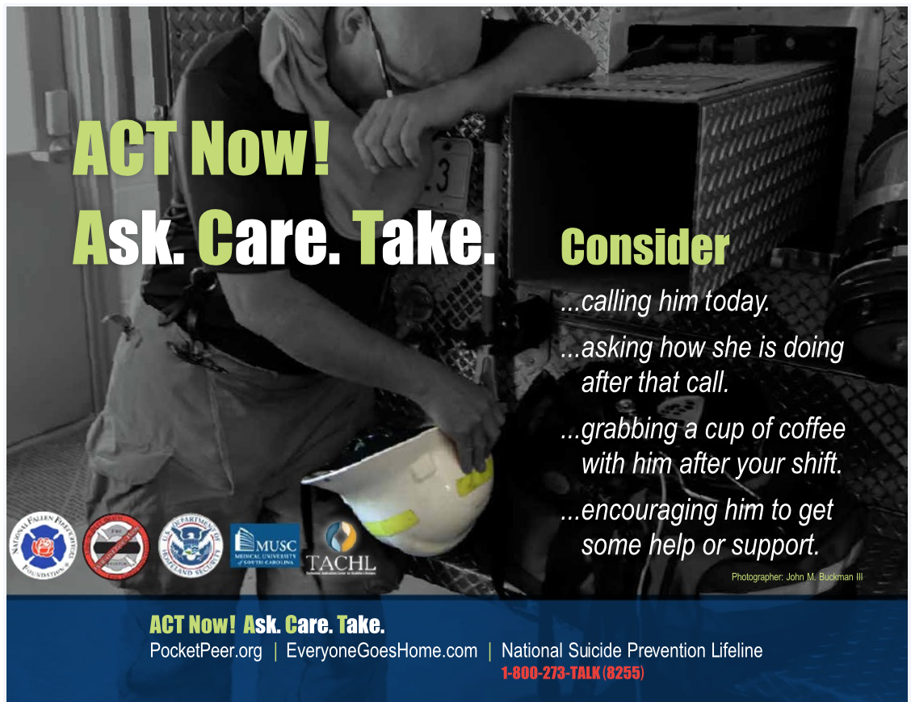
EAP counselors and staff that have a deep cultural understanding of first responders, especially those that have come from within the ranks., are in the best position to offer counseling and support. Referral programs and linkages to resources that are tailored to first responders wherever possible can reassure those in need of services that they are not being “handed off” to outsiders who would not understand.

The resource pictured was developed in partnership between organizations dedicated to firefighter health and safety, including mental health and reduced suicide risk.
Visit http://pocketpeer.org and https://www.everyonegoeshome.com to learn more about these initiatives and resources.
Training and Education
Suicide prevention training is useful on multiple levels. At a minimum, supervisors and chain of command staff should receive suicide prevention training, and where possible first responders as well. Suicide prevention and crisis de-escalation training also ensures first responders have the skills they need to do their job most effectively when they are called to intervene with community members in crisis or threatening suicide. More knowledge and skills in these areas can build confidence and resiliency.

In addition to suicide prevention training, education about mental wellness, trauma, and how to support one’s own and others well- being can be beneficial from the academy level and throughout the career. Frequent, mandatory training that is actively promoted by leadership can help normalize and institutionalize their importance.

Postvention and Event Response Protocols
When critical incidents occur, having an established protocol to address mental wellness policies among those affected. Interventions with peers and therapists together can further break down the stigma of getting mental health assistance. Post-traumatic stress is often cumulative, so opportunities for critical incident debriefing can be helpful at multiple points in time, nor just the immediate aftermath of the event.
When a fellow first responder dies by suicide, having a postvention plan in place can more effectively mobilize support and better promote healing. The postvention plan for first responder agencies should include:
- Funeral protocols that honor the service and success of the fallen first responder, regardless of the means of his or her death
- Communication from department leadership that promotes mental health resources and counseling
- Dissemination of information to the public clearly and consistently

How Can You Help?

Most of the strategies outlined above are the purview of first responder agencies themselves, and many refer to the strong preference to receive services, training and support from peers, or at least individuals who are very familiar with the culture of first responders. If you are an “outsider” this may leave you wondering how you can help.

There are many people who have a role to play in preventing suicide among first responders. The attitudes and behaviors of health care providers, family, friends, faith leaders, and others can all influence first responders’ health and well-being.

As with any outreach process, the most important step is to offer your willingness to learn and to help in ways that the first responder agencies would find most useful. Below are some suggestions for ways your agency or organization might be able to support first responder agencies in the important work they are doing taking care of their own.

- During Suicide Prevention Week or beyond, share the materials included with the 2019 Suicide Prevention Activation Toolkit with first responder agencies. The template letter for leadership, and newsletter drop-in article, can be customized to individual agencies to change culture and provide information on resources.

- Promote first responder specific crisis resources such as Copline, Share the Load, and SafeCallNow (noted above).

- Use your familiarity with Know the Signs and Each Mind Matters to offer assistance with launching a similar campaign within first responder agencies. Work with them to identify the goals of the campaign and brainstorm how existing materials and resources can further those goals.

- Offer a menu of suicide prevention trainings. If current trainers are not available that specialize in training first responders, help build this capacity by partnering with the agencies to have some of their own staff trained in ASIST or another gatekeeper training.

- Find out if the agency has a peer counseling or peer support program on site; if not, offer to help build one through partnering with NAMI or another group that has expertise in facilitating successful peer support models.

- Assess if you have clinicians on staff, or in the community, who have experience or training in first responder mental health. Ask how they can be made available to support first responders routinely and/or after critical incidents.

- Share the Community Postvention Guide and discuss how you can support the development of postvention after suicide plans and protocols within agencies as well as the community.

Peterson C, Stone DM, Marsh SM, et al. Suicide Rates by Major Occupational Group — 17 States, 2012 and 2015. MMWR Morb Mortal Wkly Rep 2018;67:1253–1260. DOI: http://dx.doi.org/10.15585/mmwr.mm6745a1
Erratum: Vol. 67, No. 45. MMWR Morb Mortal Wkly Rep 2019;68:186. DOI: http://dx.doi.org/10.15585/mmwr.mm6807a7
Dill J., Douglas R., Heyman M. The Ruderman White Paper on Mental Health and Suicide of First Responders. Ruderman Family Foundation https://rudermanfoundation.org/white_papers/police-officers-and-firefighters-are-more-likely-to-die-by-suicide-than-in-line-of-duty/
Quinet, K. D., Bordua, D. J., & Lassiter, W. (1997). Line of duty police deaths: A paradoxical trend in felonious homicides in the United States. Policing and Society, 6(4), 283–296. http://doi.org/10.1080/10439463.1997.9964758
SAMHSA Disaster Technical Assistance Center, Supplemental Research Bulletin First Responders: Behavioral Health Concerns, Emergency Response, and Trauma, https://www.samhsa.gov/sites/default/files/dtac/supplementalresearchbulletin-firstresponders-may2018.pdf
Ian H.Stanley, Melanie A.Hom, Christopher R.Hagan, Thomas E.Joiner. Career prevalence and correlates of suicidal thoughts and behaviors among firefighters. Journal of Affective Disorders, Volume 187, 15 November 2015, Pages 163-171
Ian H.Stanley, Melanie A.Hom, Thomas E.Joiner, A Systematic Review of Suicidal Thoughts and Behaviors Among Police Officers, Firefighters, EMTs, and Paramedics. Clinical Psychology Review, Volume 44, March 2016, Pages 25-44
Violanti, J. M., Fekedulegn, D., Charles, L. E., Andrew, M. E., Hartley, T. A., Mnatsakanova, A., & Burchfiel, C. M. (2009). Suicide in police work: Exploring potential contributing influences. American Journal of Criminal Justice, 34(1-2), 41–53. http://doi.org/10.1007/s12103-008-9049-8
Kessler, R. C., Borges, G., & Walters, E. E. (1999). Prevalence of and risk factors for lifetime suicide attempts in the National Comorbidity Survey. Archives of General Psychiatry, 56(7), 617. http://doi.org/10.1001/archpsyc.56.7.617
Vigil, N. H., Grant, A. R., Perez, O., Blust, R. N., Chikani, V., Vadeboncoeur, T. F., . . . Bobrow, B. J. (2018). Death by suicide—The EMS profession compared to the general public. Prehospital Emergency Care. Advance online publication. doi: 10.1080/10903127.2018.1514090.
Waters JA, Ussery W. Police stress: history, contributing factors, symptoms and interventions. Policing: An International Journal of Police Strategies and Management. 2007;30(2):169–88. https://www.ncjrs.gov/App/Publications/abstract.aspx?ID=241457
Ian H.Stanley, Melanie A.Hom, Thomas E.Joiner, A Systematic Review of Suicidal Thoughts and Behaviors Among Police Officers, Firefighters, EMTs, and Paramedics. Clinical Psychology Review, Volume 44, March 2016, Pages 25-44
Violanti JM, Aron F. Sources of police stressors, job attitudes, and psychological distress. Psychol Rep. 1993;72(3 Pt 1): 899–904 https://www.ncbi.nlm.nih.gov/pubmed/8332691
Cooper CL, Davidson MJ, Robinson P. Stress in the police service. J Occup Med. 1982;24(1):30–6. https://www.ncbi.nlm.nih.gov/pubmed/7054479
Rollin McCraty and Mike Atkinson, Resilience Training Program Reduces Physiological and Psychological Stress in Police Officers. Global Advances in Health and Medicine 1, no. 5 (November 2012): 44–66.
Mishara BL, Martin N. Effects of a comprehensive police suicide prevention program. Crisis. 2012;33(3):162–168. doi:10.1027/0227-5910/a000125
SAMHSA Disaster Technical Assistance Center, Supplemental Research Bulletin First Responders: Behavioral Health Concerns, Emergency Response, and Trauma, https://www.samhsa.gov/sites/default/files/dtac/supplementalresearchbulletin-firstresponders-may2018.pdf

