May 2014 Walk In Our Shoes Media Recap Report

Media Term Definitions
Reach | Number of people within the target attendance who were exposed to the campaign message.
Frequency | Average number of times each person within the target audience was exposed to the campaign message. Some people saw one time, others 15 times.
Impressions | Total number of times message was viewed/heard by people within the target audience.
Banners | Advertisements in fixed positions on websites.
Exposure | Open eyes facing a medium-people watching, listening, and/or reaching.
Click-through Rate | Number of clicks on an ad divided by the number of times the ad is shown.

The objective of the 2014 Walk In Our Shoes media campaign was to raise awareness of the stigma associated with mental health challenges with a call to action to WalkInOurShoes.com. The successful media campaign included a combination of traditional and new media that provided reach to the target audience and frequency of message.

The campaign was active from May 5 through May 31. In order to maximize the effectiveness of the buy, we strategically targeted the youth segment in the four major metro areas in California: Los Angeles, Sacramento, San Diego and San Francisco. The campaign was comprised of a combination of radio and digital media placed with our iHeart Media partner. Added value was leveraged for the buy and used to support the Each Mind Matters event on May 13 in Sacramento.

Radio
Radio provided the campaign with broad reach in order to provide awareness of the Walk In Our Shoes site to as many people as possible. 30-second spots aired from May 5 through May 25, on one or two key stations in each market, reaching 39 percent of 6-to-17-year-olds an average of two times. Below is a summary of the radio buy delivered against English-speaking 6-to-17-year-olds:

- Markets reached:
- San Francisco (San Francisco, Sonoma, Napa, Solano, Contra Costa, Marin, Alameda, San Mateo and Santa Clara counties)
- Sacramento (Sacramento, Nevada, Placer, El Dorado and Yolo counties)
- San Diego (San Diego County)
- Los Angeles (Los Angeles and Orange counties)

Radio Recap
Dates |  | May 5 – 25
Radio Stations |  | 5
Spots (:30) |  | 480
6-to-17-Year-Olds Impressions |  | 2,829,000
6-to-17-Year-Olds  Reach % / Frequency | 39% / 2x

Digital
Digital media provided an additional touch point with our target audience through a combination of audio streaming, pre-roll video and banners running on iHeart Media radio station websites in the same metro areas as the radio campaign (see below for the list of markets reached). The banners were successful in directing 0.19 percent of the audience exposed to the message to the website. This click-through rate is well above the industry average range of 0.07 to 0.1 percent.

- Markets reached:
- San Francisco (San Francisco, Sonoma, Napa, Solano, Contra Costa, Marin, Alameda, San Mateo and Santa Clara counties)
- Sacramento (Sacramento, Nevada, Placer, El Dorado and Yolo counties)
- San Diego (San Diego county)
- Los Angeles (Los Angeles and Orange counties)
Digital Recap
Dates | May 5 – 31
Impressions | 5,581,447
Clicks to Campaign | 10,441
Click-through Rate | 0.19%
Visits to Website | 13,832

Digital Banner Ad

Website Traffic
Both the radio spots and digital banners drove audiences to view the Walk In Our Shoes website. In response, the web traffic for WalkInOurShoes.org increased significantly, in particular spikes in traffic from the four markets that ran radio spots. This surge in traffic can be attributed primarily to the digital web banners and video web banners. Combined, these two sources drove almost 71 percent of the overall web traffic to the site during the media buy period. Other traffic came to the website through organic searches, suggesting that radio spots were also successful in promoting the website and driving interested audiences to get more information.
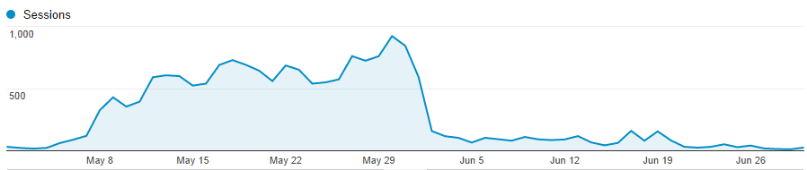

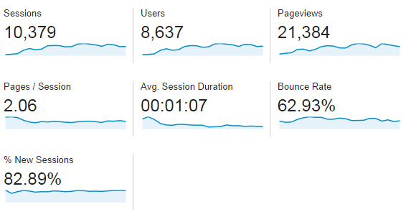
Top 5 California Cities:
- Los Angeles
- Chula Vista
- San Francisco
- Oakland
- San Diego

Added Value
In placing the 2014 media buy, RSE secured an added value campaign that was used to promote Each Mind Matters and Mental Health Matters Day on May 13. The total added value delivered for Mental Health Matters Day is estimated at $54,647, representing 38 percent in bonus exposure. The results from this added value media campaign can be found in the 2014 Each Mind Matters Media Recap Report.
Summary
The media campaign included a variety of elements to reach the Walk In Our Shoes and Each Mind Matters target audiences. Each media component showed strong results, with radio in particular demonstrating effectiveness at delivering stigma and discrimination reduction messages to 39 percent of the target audience an average of two times. In total, this campaign delivered more than 2.8 million targeted impressions to the tween and youth audience segment.

